

Sensors Creativity Board

Documentation (V1.0)

# 1. Overview

The ZAS Robotics Sensors Creative Board’s features are grouped into 9 blocks.

1. Power Block
2. Arduino Block
3. Basic Electronic Components Block
4. Potentiometer Block
5. Sensors Block
6. Bluetooth Block
7. Ultrasonic Sensor Block
8. Breaboard and Free Connectors Block
9. OLED Block

The functionality and features of each block is discussed in the following sections.

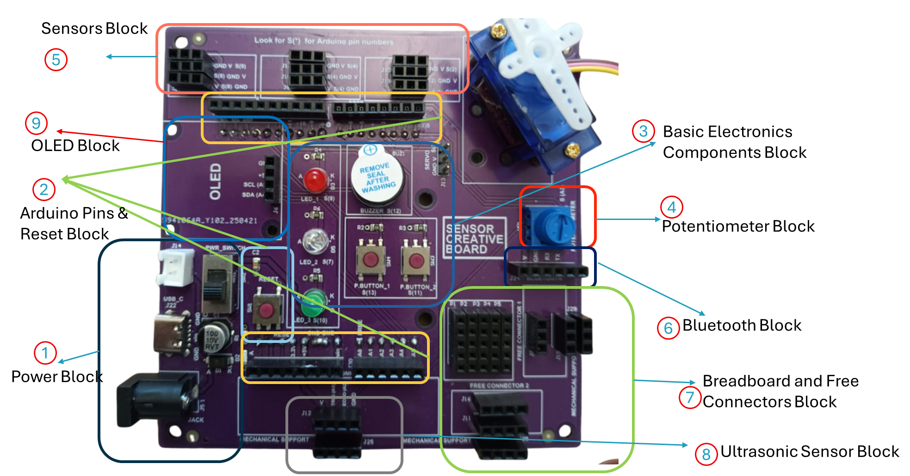

Figure 1. ZAS Robotics Sensors Creative Board Functional Block Diagram

# 2. Power Supply Block

The power block is shown in the following Figure. 2

The creativity board can be powered by:

* DC jack (5v to 7.4v) or
* USB-C Cable (5v)
* JST XH Battery Connector (3.7v to 7.4v)

In addition, the board also has an on/off switch to control the power input to the board.

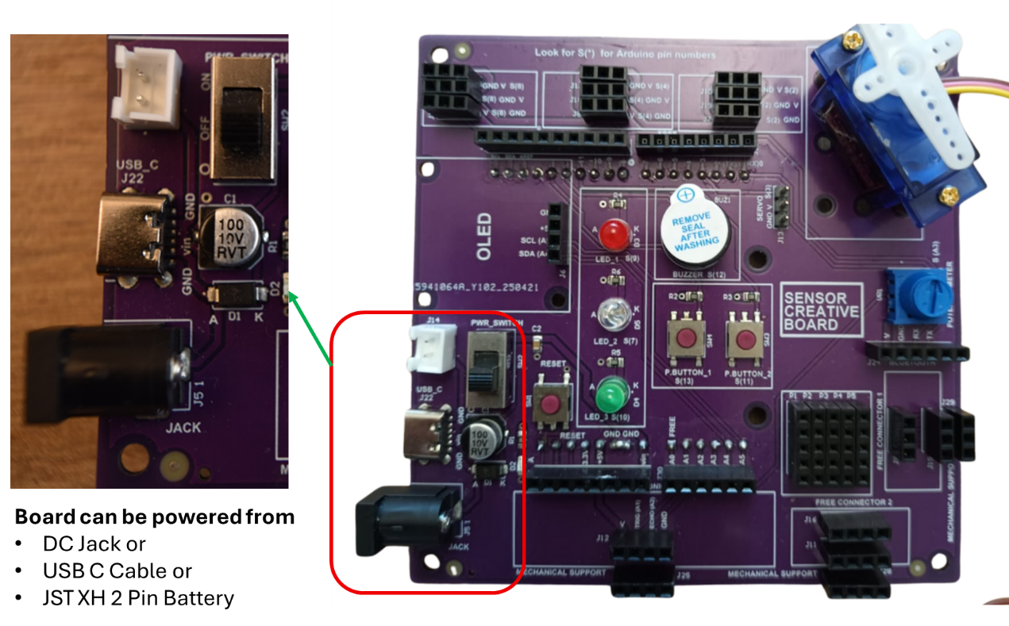

Figure 2. ZAS Robotics Sensors Creative Board – Power Supply Block

# 3. Arduino Block

The sensor creative board exposes the Arduino UNO microcontroller PINS as shown in Figure 2.

In addition, the board has a Reset button, which is connected to the reset pin of the Arduino, which can be used to restart the Arduino.

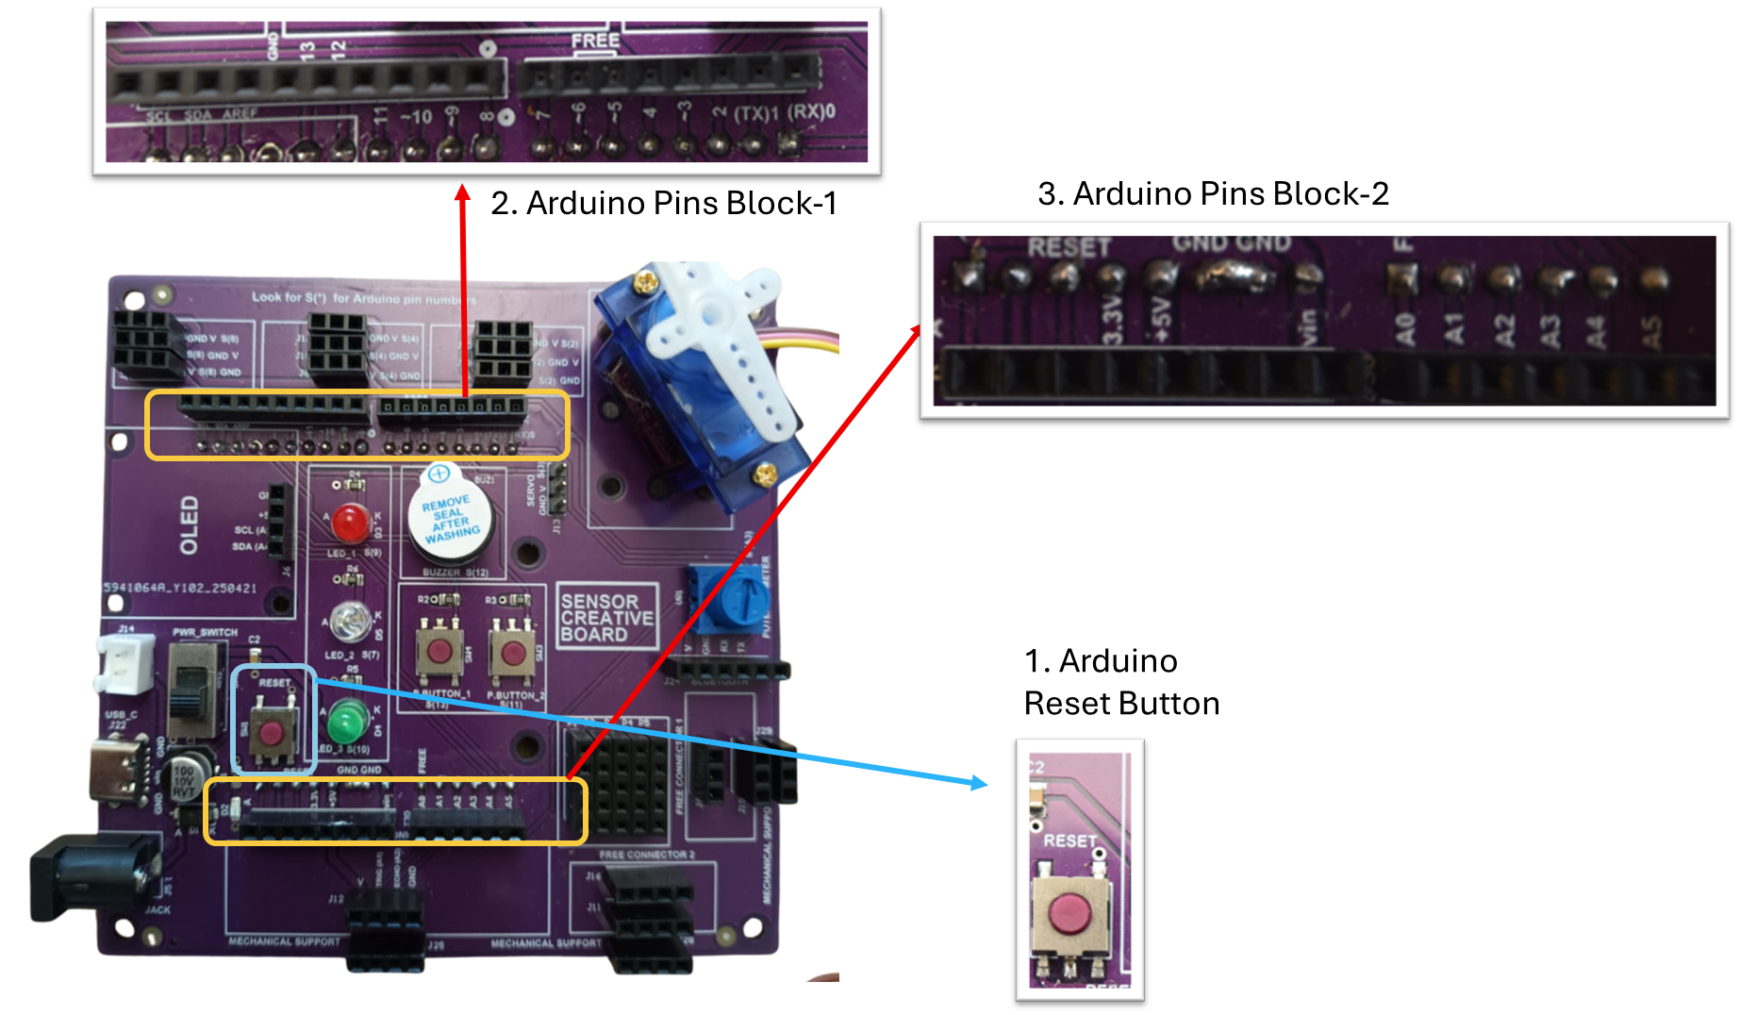

Figure 3. ZAS Robotics Sensors Creative Board – Arduino Pins Block

# 4. Basic Electronic Components Block

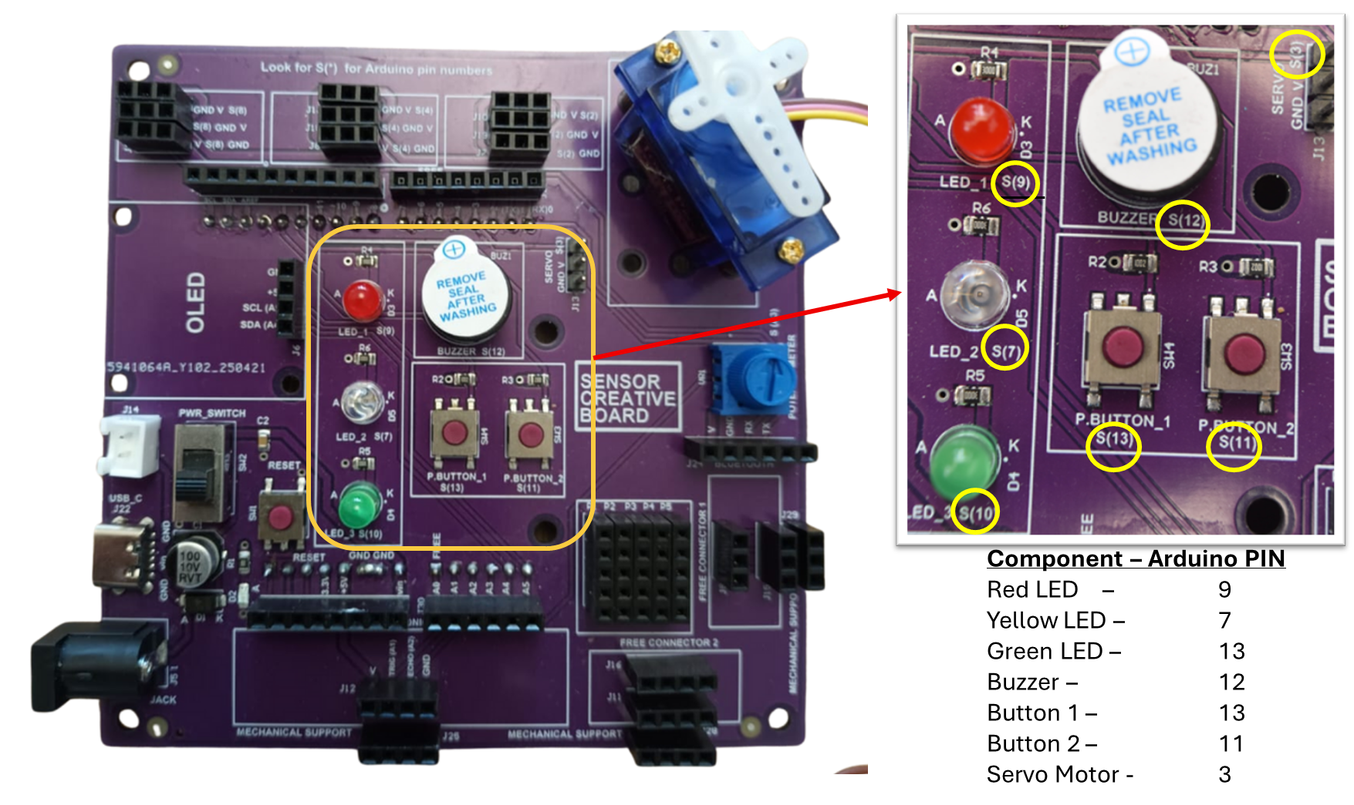

Figure 4. ZAS Robotics Sensors Creative Board – Basic Electronic Components Block

The basic electronic components such as LED, Buzzer, Buttons and Servo Motor connector is connected to the Arduino PINS as described in the table below.

|  |  |
| --- | --- |
| **Component Name** | **Connected to Arduino PIN** |
| RED Led | 9 |
| YELLOW Led | 7 |
| GREEN Led | 13 |
| Buzzer | 12 |
| Button 1 | 13 |
| Button 2 | 11 |
| Servo Motor (3 Pin Connector) | 3 |

# 5. Potentiometer Block

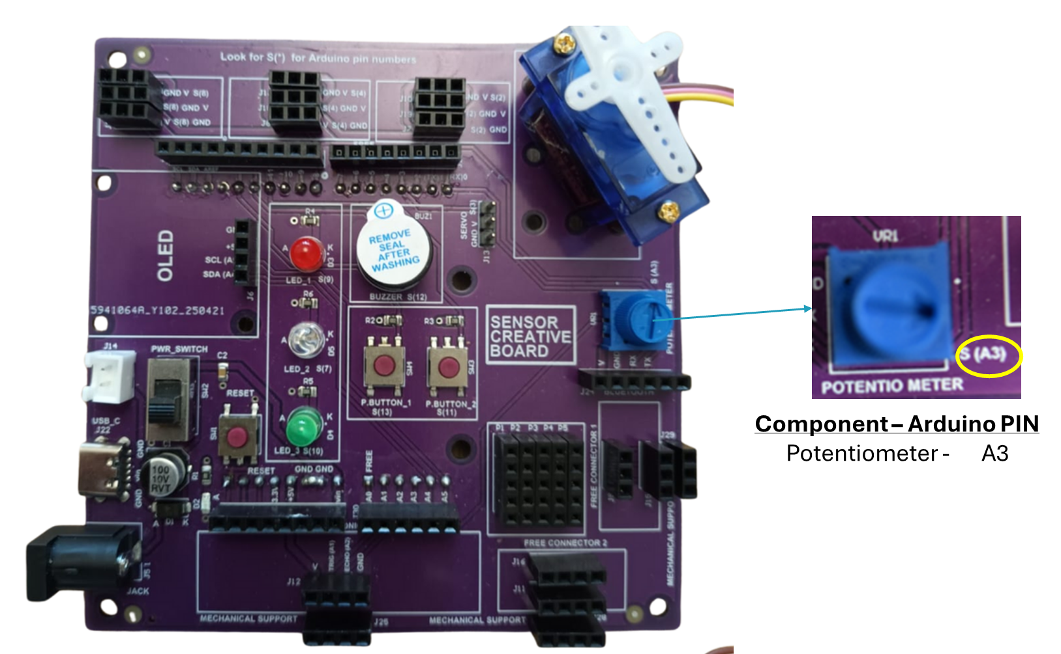

Figure 5. ZAS Robotics Sensors Creative Board – Potentiometer Block

The sensor creative board exposes a potentiometer which is connected to the Arduino Pin A3.

# 5. Sensors Block

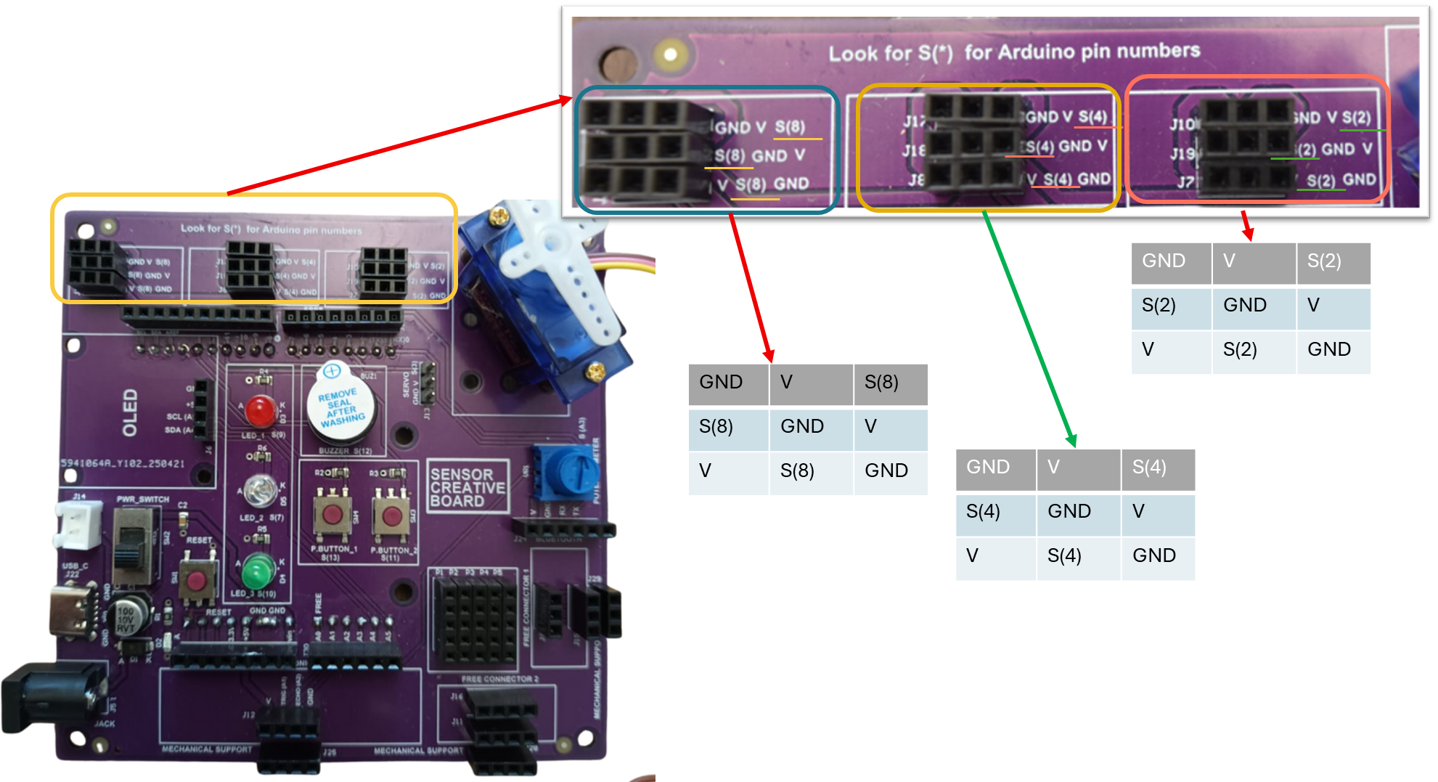

Figure 6. ZAS Robotics Sensors Creative Board – Sensors Block

The ZAS Creative Board exposes 3 connector blocks to connect any sensor which has 3 PINS (Voltage, Ground & Signal/Data).

## Special Note

* Please note that there are three sub-blocks in the sensors block.
* To each sensor sub-block, there is only 1 three three-pin sensor that can be connected. To be more specific,
  + The first sensor block is connected to Pin 8 of the Arduino
  + The second sensor block is connected to Pin 4 of the Arduino
  + The third sensor block is connected to Pin 2 of the Arduino
* To understand the rationale behind the design of each sub-block, which has 3 rows of Dupont female pins , let's take one of the sub-blocks and delve into the details. As an example, here sub-block which is connected to Pin-4 is taken.

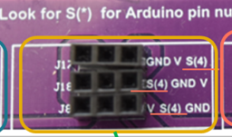 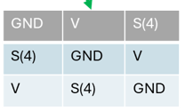

* The reason for the three rows of 3-pin Dupont is to accommodate sensors which are labelled in different combinations. For example, as shown in the figure below, the temperature sensor pins sequence is – “Signal/Data, V, and GND”. The touch sensor pins sequence is – “GND, V and Signal/Data” and similarly, the IR sensor pins sequence is – “Signal, GND and V”.

|  |  |  |
| --- | --- | --- |
| **Temperature Sensor** | **Touch Sensor** | **IR Sensor** |
| * A close-up of a blue electronic device    AI-generated content may be incorrect. |  |  |
| G, S, V – is the pin sequence for the DHT11 temperature sensor | G, V, S – is the pin sequence for the touch sensor | S (Out/Signal/Data), G and V – is the pin sequence for the IR sensor |

.

* The pin sequence is not consistent in the three-pin sensors that is available in the market. Therefore, the ZAS Robotics sensor creative board sub-block is designed to accommodate sensors that have pins in all combinations.
* For example, if you are working with a Temperature sensor, whose pin sequence matches the top row of the Dupont female housing.
* Similarly, if you are working touch sensor, its pin sequence is G/S/V, which aligns to the 2nd row of the sensor sub-block.
* Likewise, if you are working with an IR sensor, match the sensor pin sequence (S/G/V) to the corresponding row of the sensor sub-block (which in this case is the middle row) as shown in the Figure below.

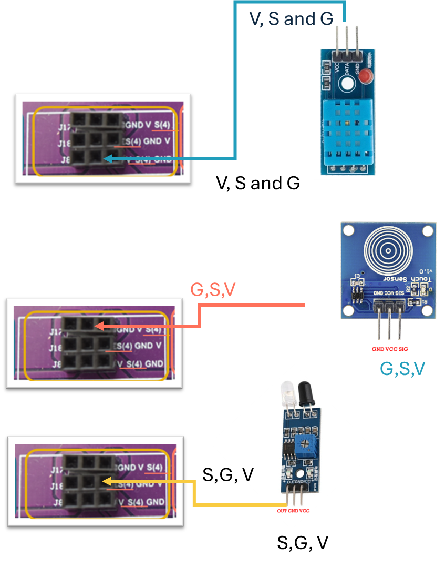

## Caution

* When you insert any 3-pin sensor into any of the sensor sub-blocks, ensure the pin sequence matches; otherwise, you risk sensor damage/burn.
* Each sensor sub-block is meant to connect only one 3-pin sensor

# 6. Bluetooth Block

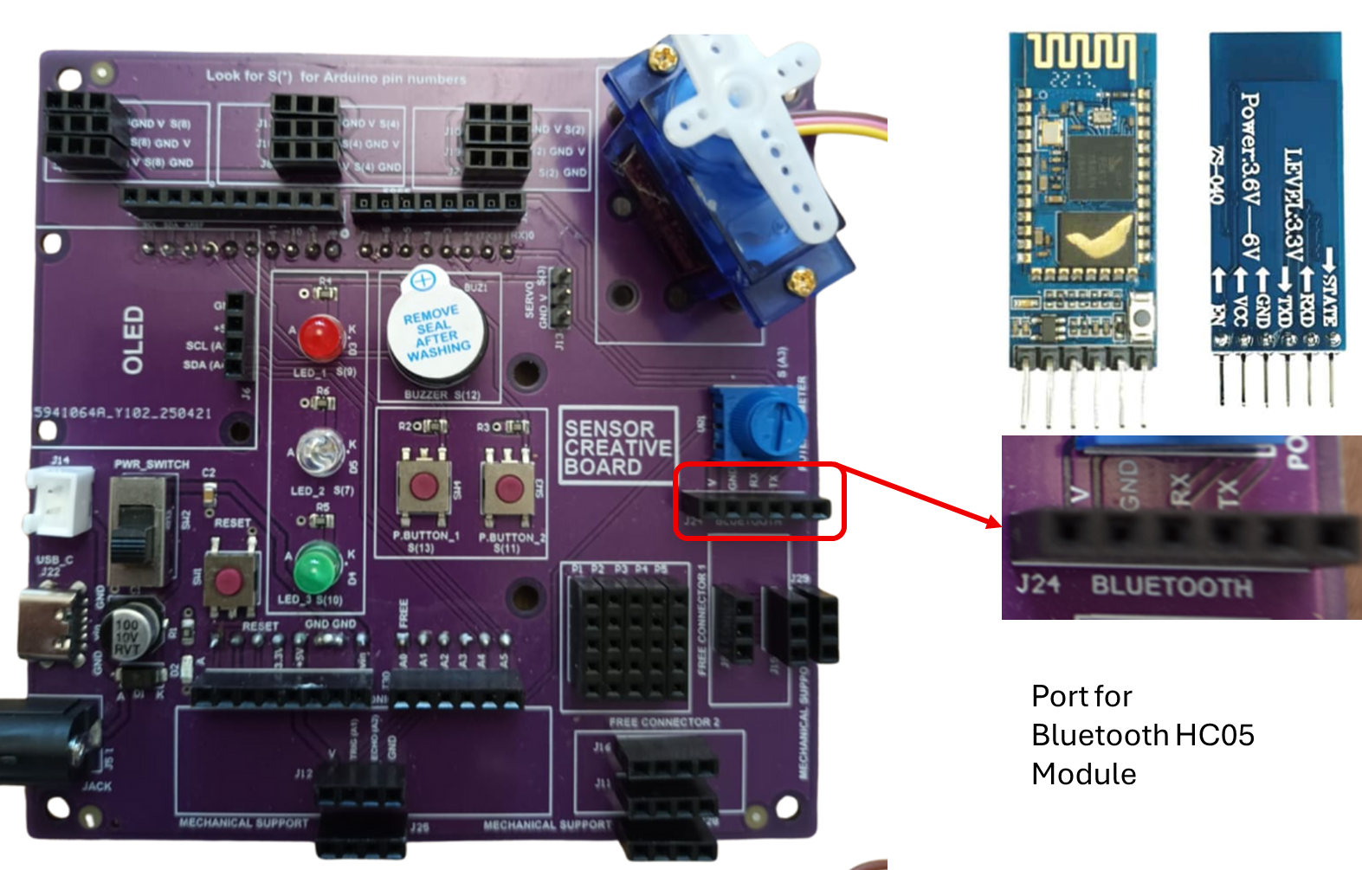

Please make a note that the Bluetooth HC05 module has 6 pins, the enable & state pins are at the extreme end, excluding these two the remaining pins are V, GND, TX & RX.

Ensure the HC05 module pins align with the Dupont female housing; otherwise, you risk the damage of the module.

# 7. Ultrasonic Sensor Block

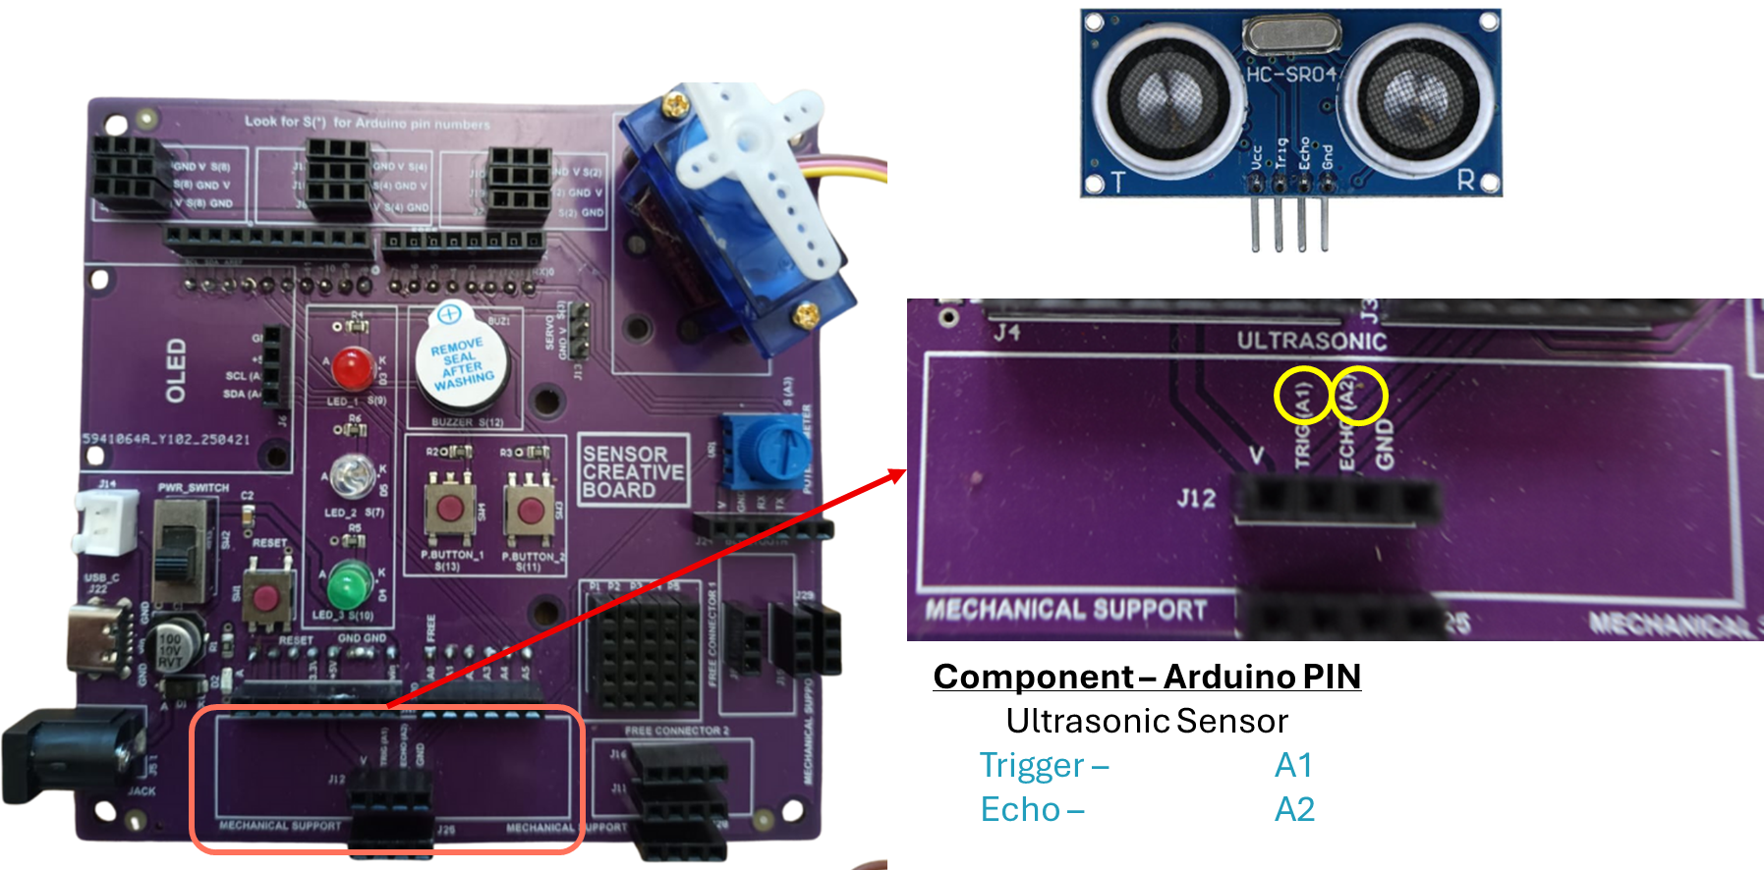

Ensure the Ultrasonic-sensor HC-SR04 module pins align with the Dupont female housing; otherwise, you risk the damage of the module.

Also, please make a note that the ultrasonic sensor block has 4 female housing connectors in parallel to the actual sensor pins housing, just to provide the mechanical support to the ultrasonic sensor. The mechanical support pins are not attached to any of the Arduino pins.

If you insert the ultrasonic sensor into the mechanical support female housing it would not work as it is not connected to any of the Arduino pins.

# 8. Breaboard and Free Connectors Block

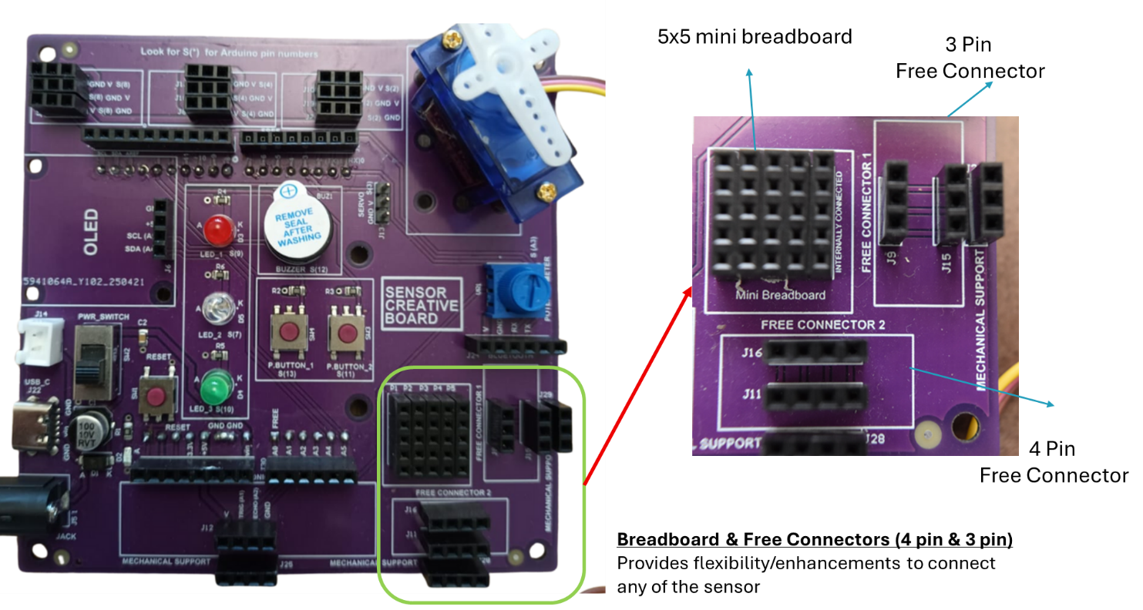

The breadboard and free connectors block are internally connected as follows:

* In case of a 4-pin free connector, J11 and J16 are connected internally (corresponding female Dupont housing). Use J11 for the sensor, J16 to connect to the Arduino pins
* In case of a 3-pin free connector, J15 and J19 are connected internally (corresponding female Dupont housing). Use J15 for the sensor, J19 to connect to the Arduino pins
* In the case of 5x5 breadboards, P1 to P5 are 5 columns, where each column is internally connected. A sample sensor connection to the breadboard is depicted below. In this example DHT11 3-Pin temperature sensor is inserted into the P2, P3, and P4 columns of the breadboard, and those columns are connected to the Arduino GND, VCC and Digital Pins of the Arduino.

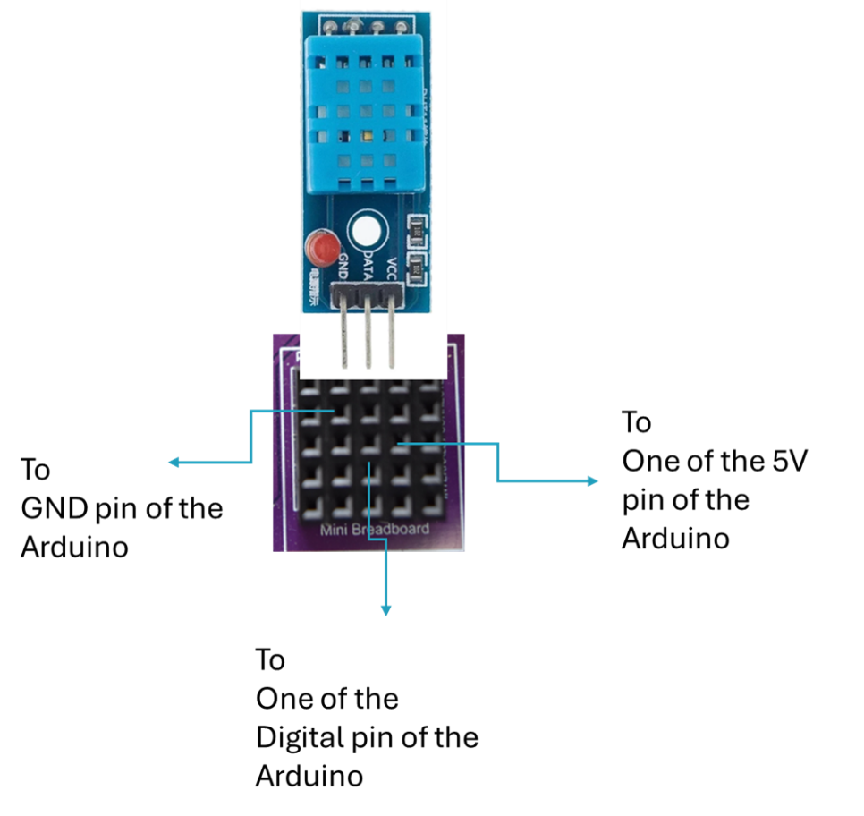

# 9. OLED Block

# 

Ensure the OLED module pins align with the Dupont female housing; otherwise, you risk the damage of the module.